

|  |  |  |
| --- | --- | --- |
| Mathematics Department | |  |
| Course: ATMAA | |
| Topic Title: Graph and Networks  Test 3 | |
| Student Name:_____________________________________ | Date: ____________ | | |
| Special Instructions: Calculator Allowed  **1 page of A4 notes and Formula Sheet Allowed** | Time Allowed: 60 mins | | |
|  | Marks: / 56 | | |

**Question 1.** **(4 marks)**

Draw a bipartite graph to represent the below information.

Student services’ is manned by five volunteers from Monday to Friday.

One volunteer is required per day.

* Abbie is available Monday, Tuesday and Friday.
* Bob is available Tuesday and Thursday.
* Cathy is available Wednesday.
* Dennis is available Tuesday, Wednesday and Thursday.
* Esther is available Monday and Friday.

**Question 2.**  **(2, 2: 4 marks)**

The diagram shows a graph with six vertices and six edges

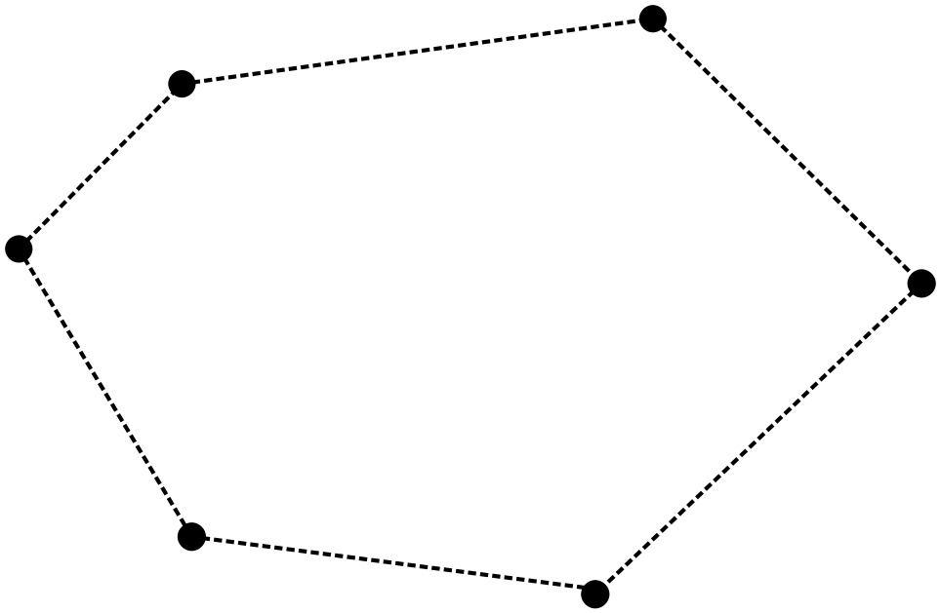

a) Explain what the term “complete graph” means:

b) Add edges to the graph so that the graph becomes a complete graph.

**Question 3.**  **(3, 3: 6 marks)**

a) ABCD is a triangular pyramid with ∆BCD as its base.

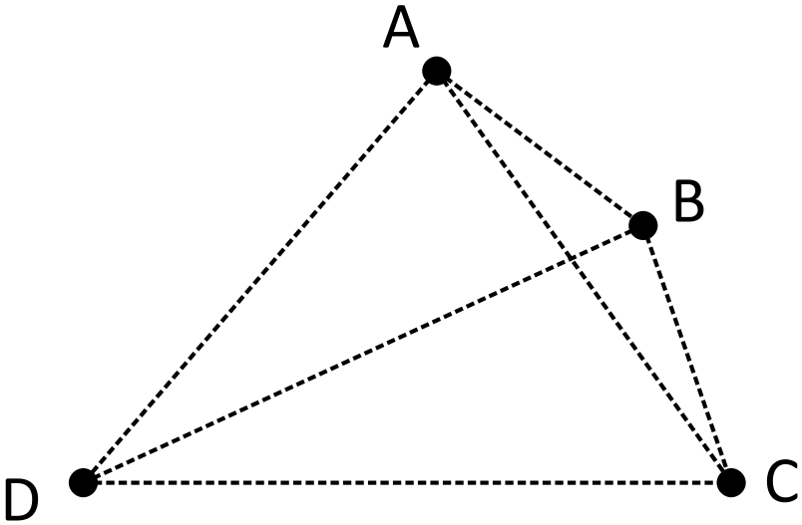

Represent the pyramid ABCD as a planar graph.

b) ABCDEF is a triangular prism with BCEF as its base.

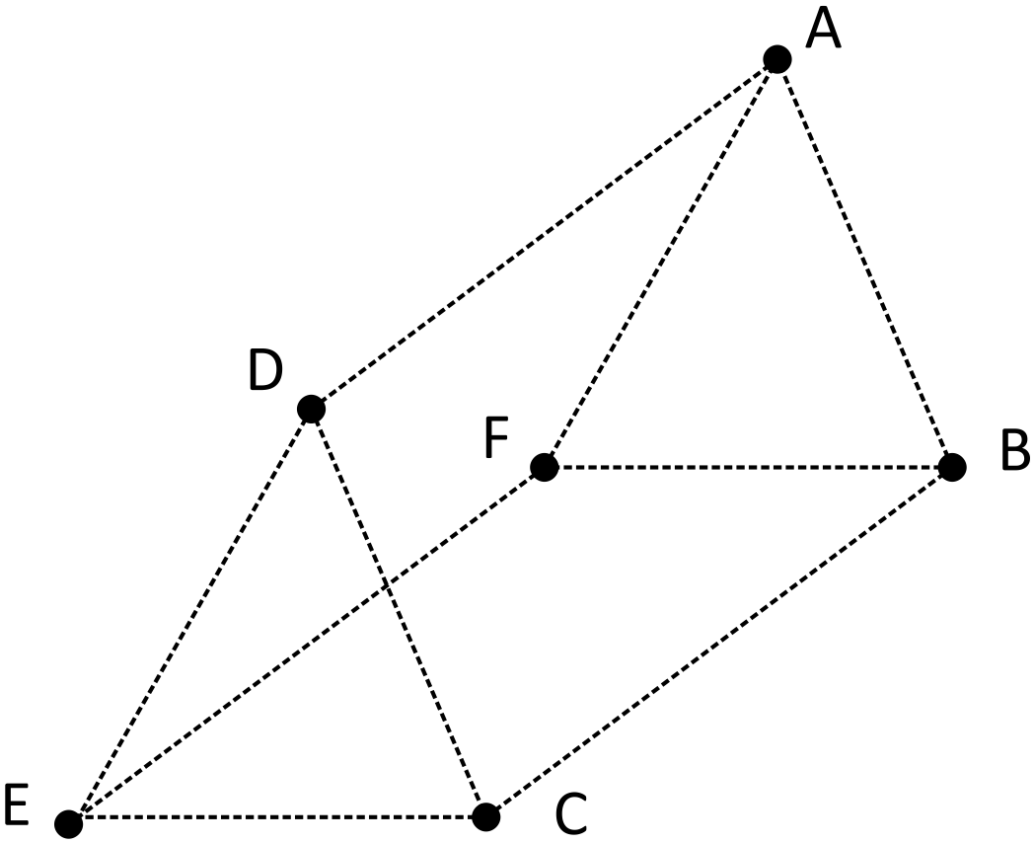

Represent the prism ABCDEF as a planar graph.

**Question 4.** **(2, 2, 2, 2, 2, 4: 14 marks)**

The accompanying diagram shows a graph.

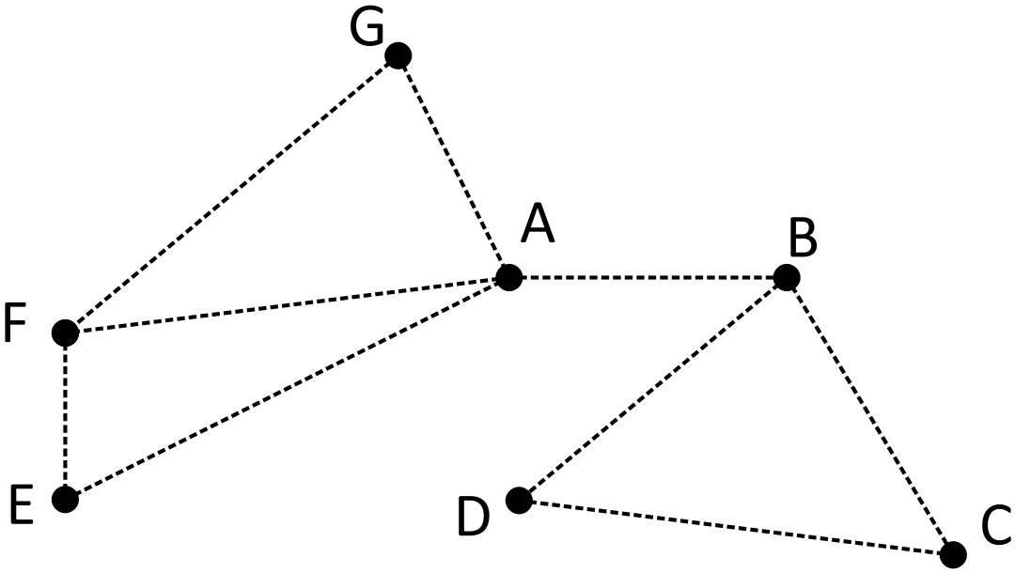

a) Determine with reasons if the graph

is simple.

b) Determine with reasons if the edge AB is a bridge.

c) This graph does not have a Hamiltonian path. Add an extra edge to this graph so that a Hamiltonian path may be formed. State this path.

d) Verify that Euler’s rule works for this graph.

e) Identify the semi-Eulerian trail in this graph.

f) Add an additional edge to the graph so that the Eulerian circuit may be formed.

i) Explain the reason for your choice.



ii) State this circuit

**Question 5.** **(4, 3, 3, 4, 3: 17 marks)**

Teams A, B, C, D and E are in Group 1 of a soccer competition where they play each other exactly once.

The results of the games are:

* A defeated B, C and E
* B defeated D
* C defeated B and E
* D defeated A and C
* E defeated B and D

a) Draw a digraph that represents the results of these matches where a directed edge points from the winning teams to the losing teams.

b) The digraph in (a) can be expressed as an adjacency matrix **M.** The element “1” is to indicate a win and the element “0” to indicate a loss.

Complete the matrix **M**

A B C D E

$\left[\begin{matrix}0 & 1 & 1 & 0 & \\ 0 & 0 & & & \\ 0 & & 0 & & \\ & & & 0 & \\ 0 & & & & 0\end{matrix}\right]$

A

B

C

D

E

c) The elements in **M2** represents the number of “two-stage wins” between teams. An incomplete **M2**

is shown below. The element in row 1 column 2 indicates that A has 2 “two-stage wins”

against :

A beat E who beat B and

A beat C who beat B.

Complete the matrix **M2** below.

A B C D E

A

B

**M2** = C

D

E

d) Calculate **M + M2**. Then multiply your answer with the column matrix $\left[\begin{matrix}1 \\ 1 \\ 1 \\ 1 \\ 1\end{matrix}\right]$.

The resulting matrix gives the total number of direct win and “two-stage wins” for each

team. Use this answer to rank the teams.

e) Calculate **M + M2 + M3** . Then multiply your answer with $\left[\begin{matrix}1 \\ 1 \\ 1 \\ 1 \\ 1\end{matrix}\right]$.

Use this answer to rank the teams.

**Question 6.** **(5, 6: 11 marks)**

When John retired, he drove around mainland Australia with his wife Janet in their Winnebago.

The diagram below shows the amount of diesel John and Janet used for each part of their journey.

The average price of diesel was $2.00 per Litre.

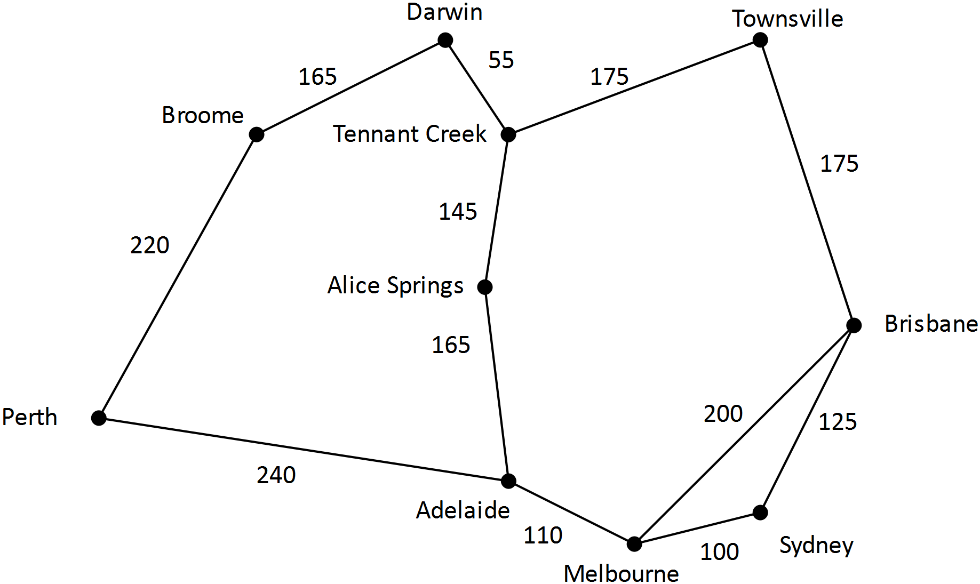

a) **State**  the route from Sydney to Broome for which the cost of diesel usage is a minimum

and state the diesel cost for this route.

b) From Sydney, John and Janet visited each of the towns listed at least once.

John and Janet complete their journey in Sydney.



a) **State** the route for which the cost of diesel usage is a minimum and state the diesel cost

for this route.